My EMS

An Environmental Management Systems (EMS) Workbook for

< Insert farm or ranch name here. >

Approved by: _____________________________ Date: _________
(Signature)

Approved by: _____________________________ Date: _________
(Signature)

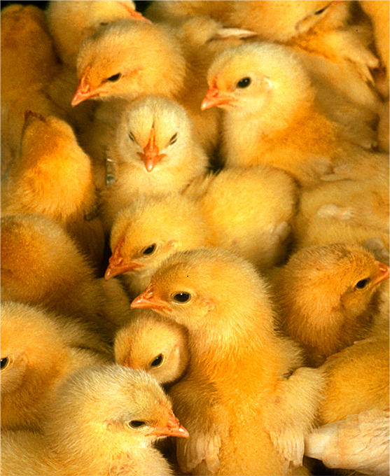
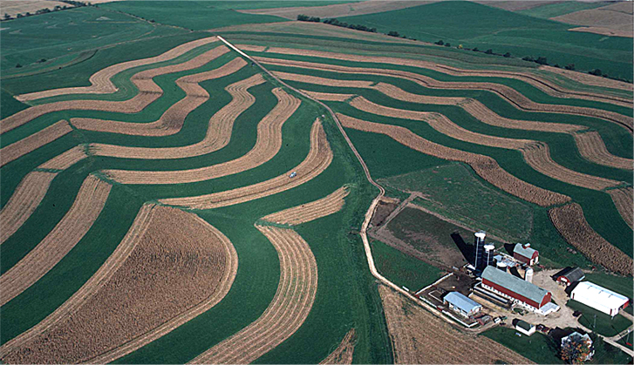

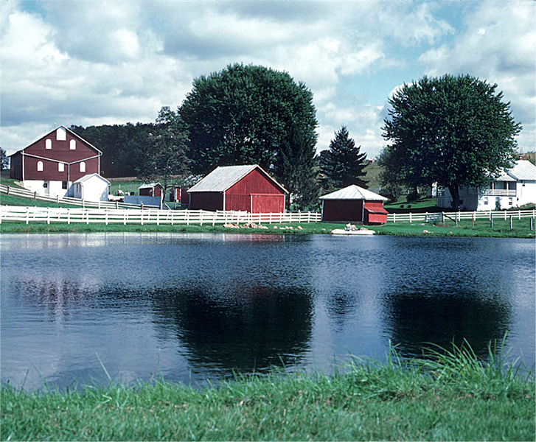

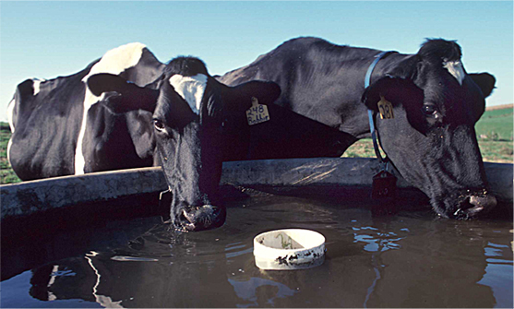

Developed by the Partners for Livestock EMS Project

Financial Support
This publication was produced as part of the "Partnerships for Livestock Environ-mental Management Assessment Systems" (EMS) Project. The project was funded by USDA-CSREES Initiative for Future Agriculture and Food Systems grant,
award #00-52103-9650. Principal investigators for this project include Gary Jackson, University of Wisconsin, 608-265-2773; Rick Koelsch, University of Nebraska, 402-472-4051; Elizabeth Bird, now at Montana State University, 406-994-2520; Bill Bland, University of Wisconsin, 608-262-0221; and Mark Risse, University of Georgia, 706-542-9067.

Disclaimer
The Partners for Livestock EMS products reflect the best professional
judgment of the contributing authors and are based on information available
as of the publication date.

Copyright © 2005 by MidWest Plan Service.
Iowa State University, Ames, Iowa 50011-3080.

For copyright permission, contact MidWest Plan Service (MWPS) at 515-294-4337. Organizations may reproduce the EMS products for non-commercial use, provided they acknowledge MWPS as the copyright owner and include the following credit statement:

Reprinted from Partners for Livestock EMS My EMS Workbook, authored by
Jill Heemstra and Rick Koelsch, University of Nebraska, courtesy of MidWest
Plan Service, Iowa State University, Ames, Iowa 50011-3080
Copyright © 2005.

Acknowledgments
The Partners for Livestock EMS team consists of representatives from Georgia, Idaho, Iowa, Montana, Nebraska, New York, North Carolina, Pennsylvania, Texas, Utah, Virginia, and Wisconsin. Individuals from these states were involved in the development, review, delivery, and update of the materials. Over 200 producers also participated in this pilot project. For more information about the Partners Project and agriculture EMS, visit the website at http://www.uwex.edu/AgEMS or http://ems.unl.edu.

Contents Page

My EMS Workbook 1

Environmental Policy Statement
Work Sheet 1. Significant Environmental Issues 2
Work Sheet 2. My Environmental Policy Statement 3

Plan
Work Sheet 3. Communications 4
Work Sheet 4. What are My Priorities? 5
Work Sheet 5. Assessments Completed 6
Work Sheet 6. Stewardship Plan for:
7
8
9
10

Implement
Work Sheet 7. Training Needs 11
Work Sheet 8a. Environmental Records 12
Work Sheet 8b. EMS Records 13
Work Sheet 9. Standard Operating Procedures (SOPs) 14
Work Sheet 10. Emergency Response Plans (ERPs) 15

Check and Correct
Work Sheet 11. Audit 16

Review and Improve
Work Sheet 12. Management Review 17

My EMS Workbook

Purpose
This workbook is meant to be a flexible template guiding the development of your EMS. As you work through the process and apply it to your operation, you will find that some steps require a great deal of effort while others can be handled with few written details. An EMS is a long-term process, a way of planning, implementing, checking, and improving your unique system. For that reason, you are encouraged to change these materials as needed to enable your EMS to be efficiently integrated into
your long-term environmental stewardship efforts.

The workbook is divided into five sections: Environmental Policy Statement Plan, Implement, Check
and Correct, and Review and Improve. Each section contains a varying number of work sheets to guide you through each step of the EMS process. As you systematically continue through the workbook, you will complete
- Two work sheets to develop your Environmental Policy Statement.
- A minimum of four work sheets to develop your Plan.
- Five work sheets to Implement the plan.
- One work sheets as you Check and Correct the plan.
- One worksheet as you Review and Improve the plan.

Work Sheet 1. Significant Environmental Issues

Purpose
This work sheet identifies environmental issues significant to your livestock or poultry operation. By identifying these issues, you are focusing your efforts on those of greatest importance to people both internal and external to the operation. In the first column, list the issues you circled on "Handout 1. Identification of Significant Environmental Issues," and in the second column, the activities related to
that issue.

Significant Environmental Issue | Farm/Ranch Activities That  Could Impact This Issue

Work Sheet 2. My Environmental Policy Statement

Purpose
This work sheet contains your environmental policy statement, which contains the baseline stewardship commitments for your operation and framework for your objectives. It needs to be communicated with those internal and also external to your operation.

Possible Topics:

Farm or ranch description and purpose?

Environmental issues significant to the farm or ranch? (from "Handout 1. ID of Significant Environmental Issues")

Stewardship commitments (from "Handout 2a. Example Stewardship Commitments")

Signature(s): Date:

Work Sheet 3. Communications

Purpose
To outline and assign responsibilities related to communication regarding the EMS and environmental performance. Change or add to these responsibilities as needed.

Internal Communication Responsibilities
All key personnel are responsible for regularly communicating with each other in the development, implementation, maintenance, and improvement of the EMS. They also are responsible for informing, encouraging, and listening to all other farm/ranch staff to help ensure proper implementation and recognition of needed improvements. Specifically,

is responsible for familiarizing new employees with the policy statement, appropriate EMS plans, and the employee’s individual responsibilities.

is responsible for evaluating if employees have the necessary skills or knowledge to carry out their assigned responsibilities.

is responsible for raising awareness about environmental regulations that may apply to the operation and regularly updating the farm manager (if they are two different people) about potential regulatory compliance issues.

External Communication Responsibilities

is responsible for responding to communication (complaints, requests) from external persons and will do so within days.

(Optional) We actively seek opportunities to share our environmental stewardship efforts with others. (In the space below, list tours or open houses you host and descriptions of your outreach efforts such as newsletters or a website. Use the back of this page if more space is needed).

(Optional) We strive to improve our communication and public image with our neighbors and surrounding communities. In the space below, list the activities you plan to implement (see "Handout 3. External Communication Ideas" for ideas).

Activity | Implementation Date
 | Proposed | Actual

Work Sheet 4. What are My Priorities?*

Directions: List your significant issues from Work Sheet 1 in the first column, then fill in the information requested in the other three columns.
When finished, circle or somehow distinguish priorities that will be expanded into a stewardship plan ("Work Sheet 6. Stewardship Plan for . . .").

Significant Environmental Issues (from Work Sheet 1) | Legal Requirements  What plans are already developed or requirements do you need to meet as  part of your permit or other legal obligations? (See "Handout 4. Environmental Regulations Affecting Animal Feeding Operations.") | Incentive Program Obligations  Do you participate in any cost share or incentive programs (EQIP, CRP, buffer strip program) that are related to this significant issue? | Assessment and Proactive Efforts  (Have you already internally identified actions of interest  or improvements needed?)
*A priority can be related items within a box, a single box, a group of boxes, a row, column, or any grouping that makes sense to you.

Work Sheet 5. Assessments Completed

Purpose
Summarize the different environmental issues or components of your system that you have reviewed for environmental risks.

Directions: Every time you complete an assessment, keep a record of the results, file it, and summarize it below.

Environmental Issue or System Component Assessed | Date Completed | Summary of Process Used (list who, any written tools used)

Work Sheet 6. Stewardship Plan for:

(List priority selected from Work Sheet 4.)
1. What is the environmental objective of this plan?

2. How will I measure performance?

3. Are legal requirements associated with this issue?
Description or Permit Title/Agency | Date Issued | Renewal Date | File Location

4. What will be done? List critical steps.¹ | Who is responsible? | Deadline or frequency?
¹If an existing environmental permit or plan has already been developed, reference the permit or plan and summarize the most critical steps associated with the permit or plan.

Work Sheet 6. Stewardship Plan for:

(List priority selected from Work Sheet 4.)
1. What is the environmental objective of this plan?

2. How will I measure performance?

3. Are legal requirements associated with this issue?
Description or Permit Title/Agency | Date Issued | Renewal Date | File Location

4. What will be done? List critical steps.¹ | Who is responsible? | Deadline or frequency?
¹If an existing environmental permit or plan has already been developed, reference the permit or plan and summarize the most critical steps associated with the permit or plan.

Work Sheet 6. Stewardship Plan for:

(List priority selected from Work Sheet 4.
1. What is the environmental objective of this plan?

2. How will I measure performance?

3. Are legal requirements associated with this issue?
Description or Permit Title/Agency | Date Issued | Renewal Date | File Location

4. What will be done? List critical steps.¹ | Who is responsible? | Deadline or frequency?
¹If an existing environmental permit or plan has already been developed, reference the permit or plan and summarize the most critical steps associated with the permit or plan.

Work Sheet 6. Stewardship Plan for:

(List priority selected from Work Sheet 4.
1. What is the environmental objective of this plan?

2. How will I measure performance?

3. Are legal requirements associated with this issue?
Description or Permit Title/Agency | Date Issued | Renewal Date | File Location

4. What will be done? List critical steps.¹ | Who is responsible? | Deadline or frequency?
¹If an existing environmental permit or plan has already been developed, reference the permit or plan and summarize the most critical steps associated with the permit or plan.

Work Sheet 7. Training Needs

Purpose

To serve as a training “to-do” list. After your management review each year, you can remove this page from the workbook, file it, and create a new list for the upcoming year.

Directions: Review the activities and improvements listed in your stewardship plan(s). Identify if there are training needs for individuals with primary responsibility for critical tasks as well as those who might have to perform a particular task in the absence of the primary person.

Summarize Training Needs | Personnel Needing Training | Date Completed

If you need to maintain a record of completed training or continuing education (required in some regulatory or certification programs), you can use "Handout 7. Training Log” and incorporate it into this workbook.

Work Sheet 8a. Environmental Records

- Purpose
This work sheet summarizes the information that will be recorded to track the operation’s environmental performance.

Directions: Review your priorities (Work Sheet 4, especially your legal requirements), stewardship plans (each copy of Work Sheet 6 that you made) and summarize environmental records that are or will be kept. Make copies or insert blank paper if more room is needed.

List of Records, Checklists, or Maintenance Logs | Issues to be Addressed | What is acceptable performance?

Work Sheet 8b. EMS Records

Purpose

This work sheet summarizes the locations and retention times of important EMS records maintained by the operation.

Record | Location of File | How long are these records retained?

Assessment Results (summarized on Work Sheet 5)

Training Needs (summarized on Work Sheet 7)

Environmental Records (summarized on Work Sheet 8)

Standard Operating Procedures (SOPs)

(summarized on Work Sheet 9)

Emergency Response Plans (ERPs) (summarized on Work Sheet 10)

Completed Audit Checklists

Completed Management Review Checklists

Briefly describe how you protect your important records from loss or destruction.

Experts recommend that records be retained for at least 3 to 5 years, although some records may be retained indefinitely if the information will be useful. Regulatory agencies generally specify a minimum retention time
for required records; check your requirements to ensure compliance.

Work Sheet 9. Standard Operating Procedures (SOPs)

Purpose
This work sheet summarizes the SOPs that have been or will be developed and the information needed to ensure they are accessible, understandable, and up-to-date.

Directions: List SOPs you have already developed and answer the questions at the top of each column. Also list activities for which you plan to develop an SOP and fill in the relevant information as each task is completed. Make additional copies or insert a blank piece of paper as needed.

SOP Title (activity) | Who will develop it and when? | Where is it posted? | Do appropriate personnel understand it? | The date of the most current version is?
To ensure accuracy, our SOPs are reviewed annually (during the management review).
We will inform affected personnel, in a timely manner, about changes made to SOPs.
As soon as possible after their date of hire, we will inform and train new employees
about SOPs relevant to their job responsibilities.

Work Sheet 10. Emergency Response Plans (ERPs)

Purpose
This work sheet summarizes the operation’s ERPs and the information needed to ensure they are easily accessible, understandable, and up-to-date.

Directions: List ERPs already developed and answer the questions at the top of each column. Also list emergency situations for which you plan to develop an ERP and fill in the relevant information as each task is completed. Make additional copies or insert a blank piece of paper as needed.

Emergency Situation | Who will develop new plans and when? | Where is it posted? | Does everyone know where it is and under-stand it? | Has the plan been rehearsed? (if practical) | How often will the plan be reviewed?
 |  |  |  |  | Next:
 |  |  |  |  | Next:
 |  |  |  |  | Next:
 |  |  |  |  | Next:
 |  |  |  |  | Next:
 |  |  |  |  | Next:
As new employees are hired, they will be informed of these plans.
We will inform all staff, in a timely manner, about changes made to the content or
location of plans.

Work Sheet 11. Audit

How often will audits be conducted?

EMS Element Audited | Most Recent Audit was: | Next Audit will be:
Overall EMS (Use "Handout 11a. Audit Checklist: Overall EMS” or substitute your own checklist.)
Use "Handout 11b. Audit Checklist: Stewardship Plans” or substitute your own checklist for each of the following:
Stewardship Plan for:

Stewardship Plan for:

Stewardship Plan for:

Stewardship Plan for:

Work Sheet 12. Management Review

How often will management reviews be conducted?

EMS Element Reviewed | Most Recent Review was: | Next Review will be:
Overall EMS (Use "Handout 12a. Management Review Checklist: Overall EMS” or substitute your own checklist.)
Use "Handout 12b. Management Review Checklist: Stewardship Plans” or substitute your own checklist for each of the following:
Stewardship Plan for:

Stewardship Plan for:

Stewardship Plan for:

Stewardship Plan for:

